**User Guide**

**To upload your product on shola e-commerce**

After you logedin, browse to dashboard and select on <item list> in left side of the page.

Once you clicked on <Upload Item> under the table, you will get the form in which the product details will be filled.

Before you upload your items,you have to fill all fields.

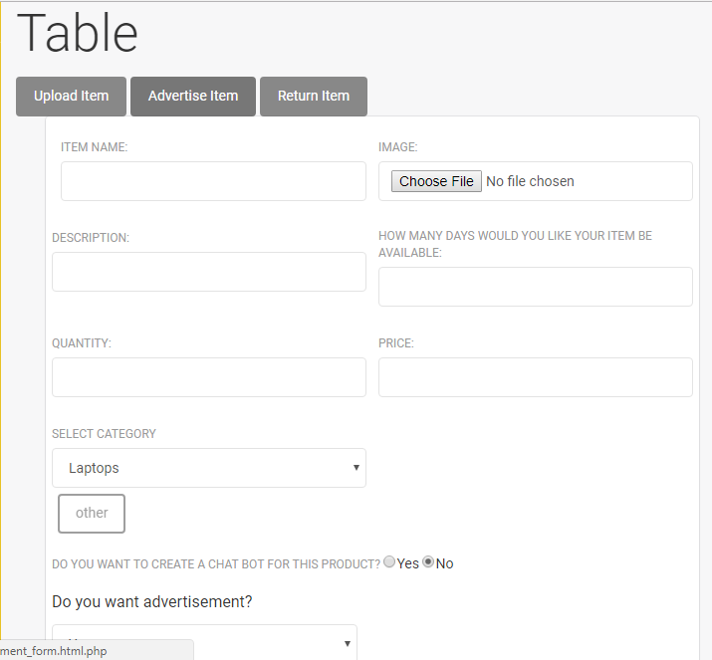

So when you <choose file> to upload your products image, the image type should be ipg, png, jpeg image types. Otherwise your product will be imageless, since the image will not be uploaded.

When you fill the <quantity >, <availability > and <price > of your product the input should be a number.

The other field can be any string.

To select the category in which your product is categorized, click the dropdown box under <select category >. If your product does not belongs to any category list, choose(click) the <other > button at the bottom of the table list page.

Finally click the <post > button to upload. You can click cancel button if you are not interested to upload the product.

Make sure that after you upload the product, you have to check whether your product is uploaded or not simply by looking your product details under <category> dropdown box or <wishlist>.

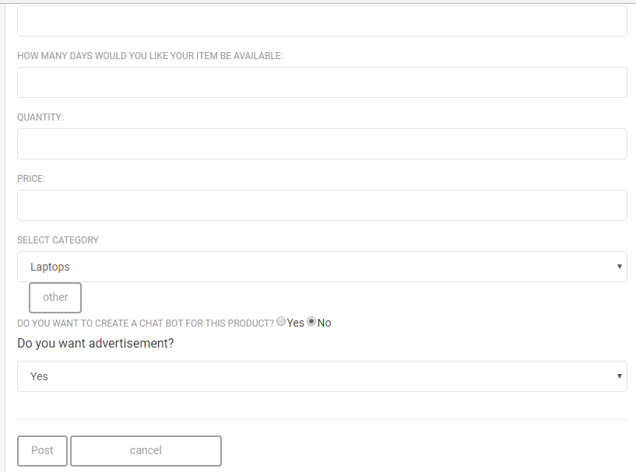

**To see the products on shola e-commerce**

Click the <category> dropdown box in the <shola> home page.

Once you clicked the category, all the category list under shola e-commerce will be display to you. Select one category list to see the available products lists for sale.